Question 1:Design an 3 hall sensor based Inner runner Rotor Brushless DC (BLDC) Motor with proper analytical modeling and FEA simulation, considering the following specifications:

Specifications:

Motor Power: 300W

Voltage: 24V

Efficiency: 95%

Power Factor: 0.95

Base RPM: 3000

Motor Outer Diameter: <70mm

Motor Stack Length: <35mm

|  |  |
| --- | --- |
| General Data | Value |
| Rated Output Power (kW) | 0.3 |
| Rated Voltage (V) | 24 |
| Number of Poles | 8 |
| Given Rated Speed (rpm) | 3000 |
| Frictional Loss (W) | 1 |
| Windage Loss (W) | 1 |
| Rotor Position | Inner |
| Type of Load | Constant Power |
| Type of Circuit | Y3 |
| Lead Angle of Trigger in Elec. Degrees | 0 |
| Trigger Pulse Width in Elec. Degrees | 120 |
| One-Transistor Voltage Drop (V) | 0.1 |
| One-Diode Voltage Drop (V) | 0.7 |
| Operating Temperature © | 60 |

|  |  |
| --- | --- |
| Full-Load Parameter | Value |
| Average Input Current (A) | 13.1454 |
| Root-Mean-Square Armature Current (A) | 11.8261 |
| Armature Thermal Load (A^2/mm^3) | 69.3234 |
| Specific Electric Loading (A/mm) | 19.3595 |
| Armature Current Density (A/mm^2) | 3.58084 |
| Frictional and Windage Loss (W) | 4.47993 |
| Iron-Core Loss (W) | 0.00127531 |
| Armature Copper Loss (W) | 7.24261 |
| Transistor Loss (W) | 2.77143 |
| Diode Loss (W) | 1.00135 |
| Total Loss (W) | 15.4966 |
| Output Power (W) | 299.993 |
| Input Power (W) | 315.49 |
| Efficiency (%) | 95.0881 |
| Rated Speed (rpm) | 4342.31 |
| Rated Torque (N.m) | 0.659723 |
| Locked-Rotor Torque (N.m) | 26.6894 |
| Locked-Rotor Current (A) | 688.594 |

|  |  |
| --- | --- |
| Stator Data | Value |
| Number of Stator Slots | 12 |
| Outer Diameter of Stator (mm) | 70 |
| Inner Diameter of Stator (mm) | 35 |
| Type of Stator Slot | 3 |
| Stator Slot hs0 (mm) | 0.5 |
| Stator Slot hs1 (mm) | 0.766201 |
| Stator Slot hs2 (mm) | 13.6903 |
| Stator Slot bs0 (mm) | 2.5 |
| Stator Slot bs1 (mm) | 5.1542 |
| Stator Slot bs2 (mm) | 12.4908 |
| Stator Slot rs (mm) | 0 |
| Top Tooth Width (mm) | 4.71239 |
| Bottom Tooth Width (mm) | 4.71239 |
| Skew Width (Number of Slots) | 0 |
| Length of Stator Core (mm) | 35 |
| Stacking Factor of Stator Core | 0.95 |
| Type of Steel | steel_1010 |
| Slot Insulation Thickness (mm) | 0 |
| Layer Insulation Thickness (mm) | 0 |
| End Length Adjustment (mm) | 0 |
| Number of Parallel Branches | 2 |
| Number of Conductors per Slot | 30 |
| Type of Coils | 21 |
| Average Coil Pitch | 1 |
| Number of Wires per Conductor | 1 |
| Wire Diameter (mm) | 1.45 |
| Wire Wrap Thickness (mm) | 0.2 |
| Slot Area (mm^2) | 124.965 |
| Net Slot Area (mm^2) | 109.177 |
| Limited Slot Fill Factor (%) | 75 |
| Stator Slot Fill Factor (%) | 74.8098 |
| Coil Half-Turn Length (mm) | 46.0127 |

|  |  |
| --- | --- |
| Rotor Data | Value |
| Minimum Air Gap (mm) | 0.5 |
| Inner Diameter (mm) | 14 |
| Length of Rotor (mm) | 35 |
| Stacking Factor of Iron Core | 0.95 |
| Type of Steel | steel_1010 |
| Polar Arc Radius (mm) | 17 |
| Mechanical Pole Embrace | 0.7 |
| Electrical Pole Embrace | 0.740217 |
| Max. Thickness of Magnet (mm) | 2.5 |
| Width of Magnet (mm) | 9.22898 |
| Type of Magnet | NdFe30 |
| Type of Rotor | 2 |
| Magnetic Shaft | Yes |

|  |  |  |  |
| --- | --- | --- | --- |
| Permanent Magnet Parameter | | | Value |
| Residual Flux Density (Tesla) | | | 1.1 |
| Coercive Force (kA/m) | | | 838 |
| Maximum Energy Density (kJ/m^3) | | | 230.45 |
| Relative Recoil Permeability | | | 1.0446 |
| Demagnetized Flux Density (Tesla) | | | 0.315082 |
| Recoil Residual Flux Density (Tesla) | | | 1.1 |
| Material | Density (kg/m^3) | Weight (kg) | Consumption (kg) |
| Armature Copper | 8900 | 0.243442 | - |
| Permanent Magnet | 7550 | 0.0495064 | - |
| Armature Core Steel | 7872 | - | 1.18433 |
| Rotor Core Steel | 7872 | - | 0.210507 |
| Total Net Weight | - | 0.788518 | - |

|  |  |
| --- | --- |
| No-Load Magnetic Parameter | Value |
| Stator-Teeth Flux Density (Tesla) | 1.59068 |
| Stator-Yoke Flux Density (Tesla) | 1.64131 |
| Rotor-Yoke Flux Density (Tesla) | 0.556615 |
| Air-Gap Flux Density (Tesla) | 0.757964 |
| Magnet Flux Density (Tesla) | 0.859442 |
| Stator-Teeth By-Pass Factor | 0.00649536 |
| Stator-Yoke By-Pass Factor | 0.00025605 |
| Rotor-Yoke By-Pass Factor | 5.65469e-005 |
| Stator-Teeth Ampere Turns (A.T) | 58.7276 |
| Stator-Yoke Ampere Turns (A.T) | 28.3506 |
| Rotor-Yoke Ampere Turns (A.T) | 1.59408 |
| Air-Gap Ampere Turns (A.T) | 369.44 |
| Magnet Ampere Turns (A.T) | -458.153 |
| Armature Reactive Ampere Turns (A.T) | 1346.33 |
| Leakage-Flux Factor | 1 |
| Correction Factor for Magnetic Circuit Length of Stator Yoke | 0.419397 |
| Correction Factor for Magnetic Circuit Length of Rotor Yoke | 0.795235 |
| No-Load Speed (rpm) | 4986.64 |
| Cogging Torque (N.m) | 0.159887 |

|  |  |
| --- | --- |
| Transient FEA Input Parameter | Value |
| Armature Winding |  |
| Number of Turns | 60 |
| Parallel Branches | 2 |
| Terminal Resistance (ohm) | 0.0172621 |
| End Leakage Inductance (H) | 9.75434e-008 |
| 2D Equivalent Value |  |
| Equivalent Model Depth (mm) | 35 |
| Equivalent Stator Stacking Factor | 0.95 |
| Equivalent Rotor Stacking Factor | 0.95 |
| Equivalent Br (Tesla) | 1.1 |
| Equivalent Hc (kA/m) | 838 |
| Estimated Rotor Moment of Inertia (kg m^2) | 3.58161e-005 |

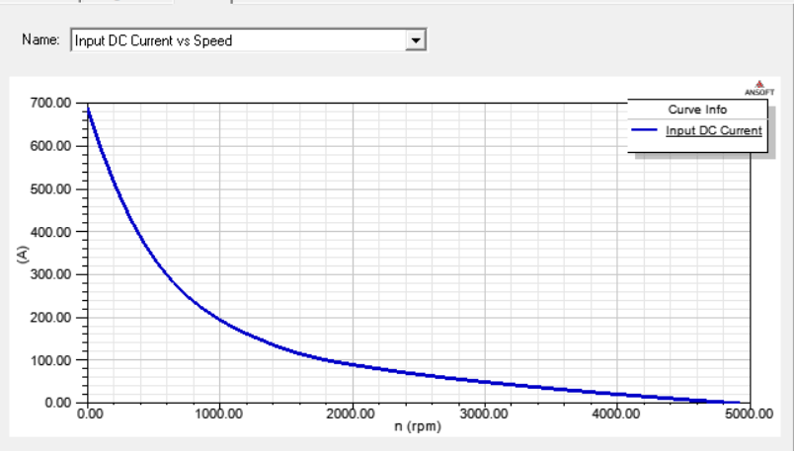

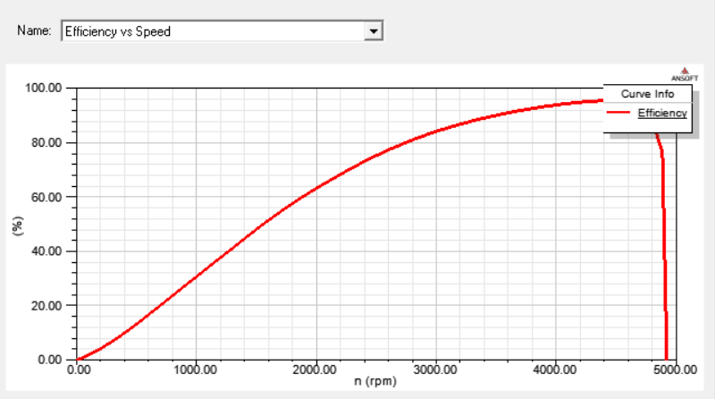

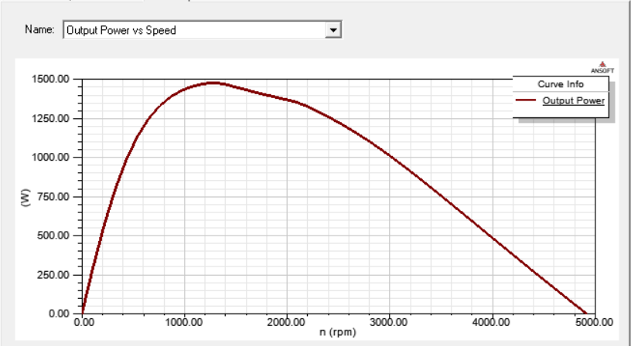

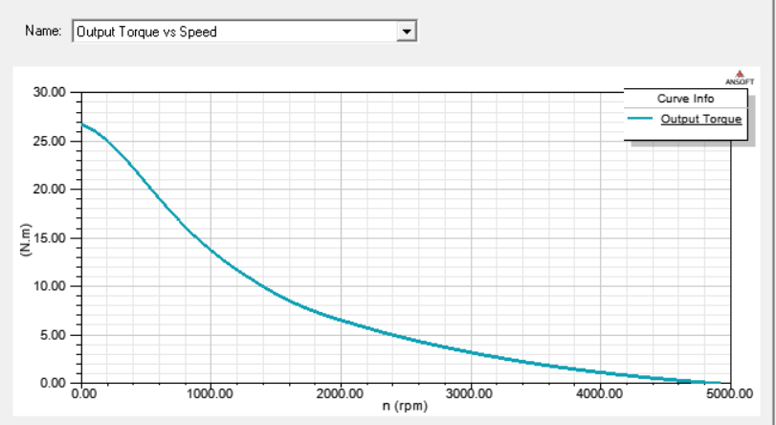





**2-D Design of Motor**:

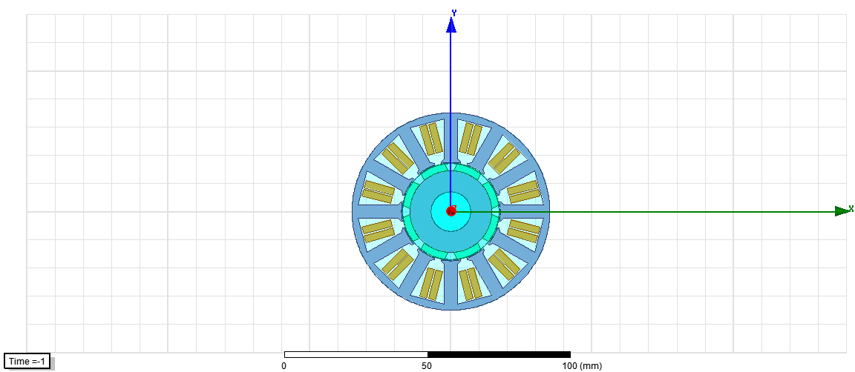

3-D Design of Motor:

